Fall Final Exam Review

1. Find the slope of the line through P(2,-1) and Q(5,7)
2. Find the slope of the line through P(5,4) and Q(3,7)
3. Graph y+5=2x, using y-intercept form.

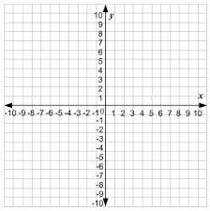

1. What is the y-intercept of question #3
2. Determine the interval on which the function is decreasing

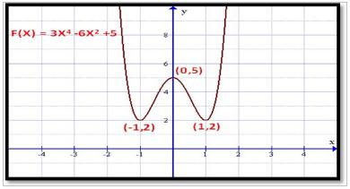

1. Find all asymptotes, holes, & domain of the function $f\left(x\right)=\frac{1}{x-2}$
2. Find all asymptotes, holes, & domain of the function $f\left(x\right)=\frac{2x^{2}-7x+3}{2x^{2}-3x-9}$
3. Let f(x)=2x+1, g(x)=3x-2. Find :
4. (f-g)(x)
5. (f+g)(x)
6. (g $°f)$ (x)
7. 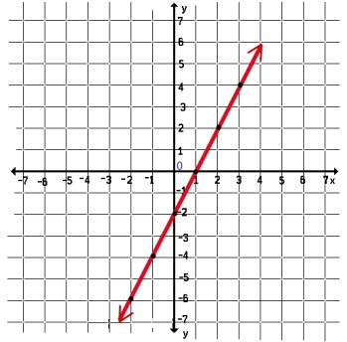Circle the function that is one-to-one:
   1. 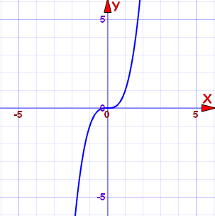Y=3x b. y= $x^{2}+3$ c. d.
8. Find the inverse of f(x)= $x^{2}+3$
9. Tell whether the function f(x)= $x^{5}+7x^{3}$ is even odd. If neither, so indicate.
10. Find a polynomial with the given zeros:

2,-3

1. Use synthetic division to perform the division $\frac{2x^{3}-17x^{2}-16x+11}{x+1}$
2. Find the domain of the rational function (state your solution in set notation, **and** interval notation): y= $\frac{x^{2}}{x-6}$

Write each expression as a sum or difference of logarithms. Then simplify, if possible.

1. 
2. 
3. 
4. 

Condense the expression, then simplify if possible

19. 

20. 

21. 

22. 

**Solve for x**

23.  24.  25. 