Introduction to Functions

Objective: SWBAT determine if a ______________, _______________, or ________________ is a __________________ or a _________________.
Helpful Hint!
X | Y
D | R
I | O
I | D
X | Y

Key terms
Term | Definition
Function

Types of Functions
Mapping: YES | 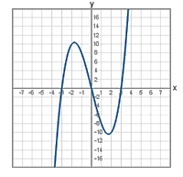  Graph: YES | Table: YES
NO | NO | NO
We Do – Guided Practice
Example 1) Determine if the following mapping represents a function by using the 1-to-1 test and a table. Justify your answer.  Input Output  Justification: |  | 2) Determine if the following mapping represents a function by using the 1-to-1 test and a table. Justify your answer.  Justification:
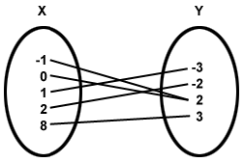  3) Determine if the following mapping represents a function by using the 1-to-1 test and a table. Justify your answer.  Input Output | Example 4) Determine if the following ordered pairs {(2,3), (-2,3), (4,7), (2,4), (-2,3)} represents a function. Justify your answer.  Justification: |  | 5) Determine if the following order pairs {(0,3),(1,3),(2,3),(-1,-3), (3,7)} represents a function. Justify your answer.  Justification:
You Do
Do at least 10 out of the 12 problems. Make sure to use resources and check your work as you go!
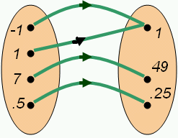  1) Determine if the following mapping represents a function by using the 1-to-1 test and a table. Justify your answer.  Justification: |  | 2) Simplify:  $$-\left(x+3\right)+4\left(3x+2y\right)-3y$$ | 3) Determine if the following order pairs {(3,3),(-3,3),(3,1)} represents a function. Justify your answer.  Justification:
4) Find the perimeter of the rectangle below.  $3x+3$  $$-2x+4$$ | 5) Determine if the following ordered pairs {(4,2), (-3,3),(6,1),(2,3)} represents a function. Justify your answer.  Justification: | 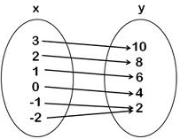  6) Determine if the following mapping represents a function by using the 1-to-1 test and a table. Justify your answer.  Justification:
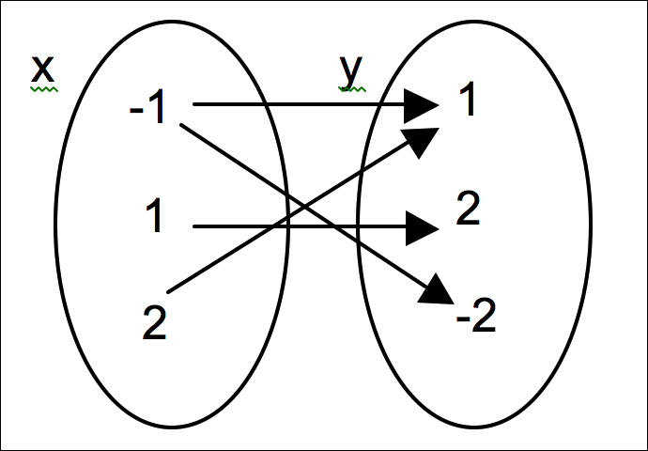  7) Determine if the following mapping represents a function by using the 1-to-1 test and a table. Justify your answer.  Justification: |  | 8) Determine if the graph is a function or relation. | 9) Solve:  $2(x +2) = -3(x –2)$
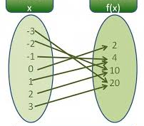  10) Determine if the following mapping represents a function by using the 1-to-1 test and a table. Justify your answer.  Justification: |  | 11) Simplify:  $$4-2\left(x+3\right)+5x$$ | 12) Determine if the graph below represents y as a function of x  